Special Tips and Guidelines for Workday End Users at UBC.
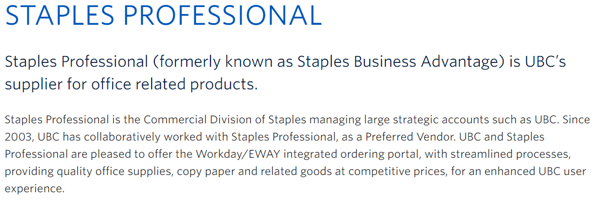
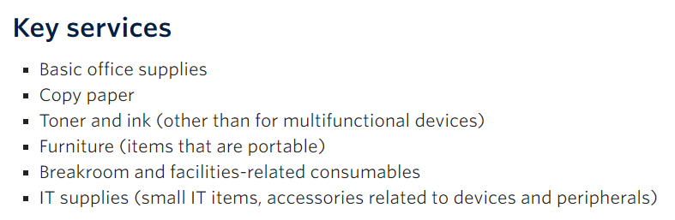
Price stabilization
- The Workday/EWAY items “In Stock“ - prices are held for one year and updated annually Nov/Dec.
- Workday/EWAY NON-Stock items from “Trusted Partners”-prices are reviewed weekly using web-scrapper technology to check major on-line suppliers and adjusting Workday/EWAY pricing to ensure items are competitively priced.
- Free delivery…no $ minimum. We recommend ordering $50 + to reduce truck traffic and to reduce greenhouse gases.
Additional Benefits and Services to UBC included in the prices
- Custom Integrated delivery through Campus Mail for a smaller carbon footprint (smaller trucks, lower Green House Gases, reduced carbon taxes) Great Sustainability for UBC.
- Custom Integrated Workday B2B with two custom catalogues; Supplies and Copy Paper, with custom routing on main Vancouver campus to support UBC vision for a more sustainable and safer campus. (fewer trucks.. fewer pedestrian mishaps).
- Experienced Customer Care team for Workday order questions, ETA, back orders updates, returns, warranty claims.
- Custom automated billing to UBC Central AP to reduce manual invoice processing.
- Custom reporting to UBC Finance for more efficient financial management.
- Dedicated Account Managers - Product category updates and experts available for consulting and solution recommendations. Lean Six Blackbelt for process streamlining and continuous improvement.
Please review our Staples Professional vendor page at UBC Finance.
https://finance.ubc.ca/list-suppliers/categories-and-suppliers/office-supplies-and-services/staples-professional
Workday Training and ISC Support teams.
- Training Course on UBC Workplace Learning: The recommended course is: Finance 301: Procurement, Receiving and Supplier Invoices – link: https://wpl.ubc.ca/browse/irp-training/courses/wpl-irp-fin301

- ISC Website – there will be a knowledge base where they can search by keyword for specific topics for step-by-step instructions, such as how to submit a Catalogue Purchase Requisition, Good Receipt Process and NON-Catalogue PO process. Website: https://isc.ubc.ca/.
- Email UBC ISC support at info.support@ubc.ca for delivery address updates & questions.

Staples Professional/Workday Procedures
1.How to Order-Orders are submitted on two UBC Workday Catalogues using a UBC CWL to login.
Supplies and Packs Paper Catalogue
Copy Paper Catalogue
Items not on these Catalogues-use our quote for the NON-Catalogue PO process.

Email, phone, or fax orders are not permitted.
2.Workday Integration Process-PO data is sent from Workday through the B2B integration and automatically routes to the Staples Professional warehouse.
PO# Must Not be Canceled for “In Stock” orders because there is not enough time to stop orders.
Once an “In Stock” item is delivered, end user can Return it for Full Credit.
3.In Stock Orders - Orders must be received on Staples Professional system by 3:00PM pacific time for these delivery times.
Vancouver Campus
Campus Mail delivers all Supplies/Packs Paper orders on the Vancouver Campus.

Delivery ETA 2-3 business days.
Contact Campus.Mail@ubc.ca for POD with signature.
Campus Mail needs Staples Professional order # and delivery address to look up POD with signature.

Staples Professional delivers all Copy Paper orders.
Contact Customer Care at easyservice@staples.com for POD with signature.

Off-Campus-Lower Mainland
Delivery ETA 1-2 business days depending on location in lower mainland.
Staples Professional delivers Supplies/ Packs Paper and Copy Paper orders.
Contact Customer Care at easyservice@staples.com for POD with signature.

Okanagan Campus
Delivery ETA 4-5 business days. (Haida Gwaii-ETA 7-10 business days)
Courier delivers all orders.
Contact Customer Care at easyserice@staples.com for POD with signature.

4.Trusted Partner items are not stocked locally and ship from suppliers back east.
ETA is calculated by adding 2 weeks (drive time) to the item “ ship time” shown for each item.
Contact Customer Care at easyservice@staples.com for POD with signature.

5.Back Ordered items are invoiced once they are shipped.
Back Ordered items can only be canceled once Customer Care confirms that the back order Has Not shipped.

Once an item has Shipped, it is on a truck and the delivery cannot be canceled.
End user Can Return the delivery for Full Credit. Request MR# from Customer Care.

Important-End user Must cancel the Back Order with Customer Care First Before they cancel the Workday PO, otherwise the invoice payment cannot be released.
6.Return Items- End User can Return items for Full Credit if item is in original packaging.
Contact Customer Care with item # and PO # in this exact format
PO-0000012345.

Customer Care will send an MR#. End User will add a note with the MR# to the return item and it will be picked up within 7 business days. Do Not Write on the packaging.

HELP on the Catalogue has our Return Policy. Please review the Staples Professional Return Policy because the # of days allowed for Returns varies by product category.
7. Goods Receipt-Once order is delivered and the invoice is on Workday, End User completes the Goods Receipt process on Workday.
Staples Professional directs end users to contact ISC Support at info.support@ubc.ca for all Workday training on the Goods Receipt process.
8. Invoice and Credits are automatically sent to UBC central AP, through the Integration, once the order has shipped.
Please contact UBC ISC Support at info.support@ubc.ca for training or if your invoice is not on Workday within a few days after delivery.
Please allow 1-3 weeks for credit processing to allow returns to reach or warehouse.
9.Price Discrepancy- Please email Kathleen.hatami@staples.com if your Workday PO price does not match the Staples Professional invoice price.
10. Duplicate Invoice on same PO#-If you sent your PO through the Workday integration, please do not email the PO again to the Staples Professional team. This can create a duplicate order and duplicate invoice. If a duplicate order/invoice occurs, you will be contacted directly by our Customer Care team, for your credit card detail, to pay for the second order/duplicated invoice.
11.Furntiure on the Supplies Catalogue will be delivered In Box. Contact Kathleen.hatami@staples.com to arrange the extra assembly/installation charge. Quote will be provided.
12. Product Requests for NON-Catalogue items- Large Furniture Projects and Offices, plus technology, and ergonomic products. For quotes with special UBC discounts, please contact…….
Kathleen.hatami@staples.com Strategic Account Leader – UBC Lower Mainland
Alan.Homeniuk@staples.com Account Manager-UBC Okanagan
July 11, 2022
Kathleen Hatami
Strategic Account Leader
Staples Professional

